**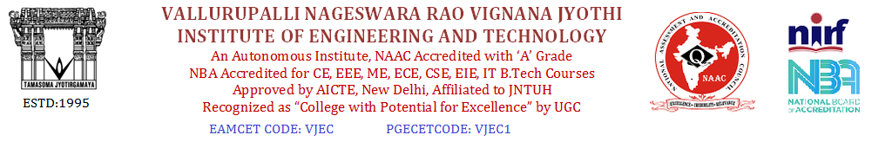**

**Summary report on WIT & WIL**

Name of the Faculty: Dr.B. Ashok Name of the Subject: Engineering Physics

Class/Section: EIE-II Date: 25-04-2019

|  |  |  |
| --- | --- | --- |
| Sl.No. | Particulars | To be filled |
| 1. | Grid Reference No. | 2.5 & 2.6 |
| 2. | Scenario Reference No.  (Mapping with syllabus) |  |
| 3. | Topic covered in every class | Introduction to Optical fibers and TIR (Revision) |
| 4. | Brief write-up (500 words) for every class:  The advantages of optical fiber communication with respect to copper wire systems are:   * **Broad bandwidth**: A single optical fiber can carry over 3,000,000 [full-duplex](https://en.wikipedia.org/wiki/Duplex_(telecommunications)) voice calls or 90,000 TV channels. * **Immunity to electromagnetic interference:** Light transmission through optical fibers is unaffected by other [electromagnetic radiation](https://en.wikipedia.org/wiki/Electromagnetic_radiation) nearby. The optical fiber is electrically non-conductive, so it does not act as an antenna to pick up electromagnetic signals. Information traveling inside the optical fiber is immune to [electromagnetic interference](https://en.wikipedia.org/wiki/Electromagnetic_interference), even [electromagnetic pulses](https://en.wikipedia.org/wiki/Electromagnetic_pulse) generated by nuclear devices. * **Low attenuation loss over long distances:** Attenuation loss can be as low as 0.2 dB/km in optical fiber cables, allowing transmission over long distances without the need for [repeaters](https://en.wikipedia.org/wiki/Repeater). * **Electrical insulator:** Optical fibers do not conduct electricity, preventing problems with [ground loops](https://en.wikipedia.org/wiki/Ground_loop_(electricity)) and conduction of [lightning](https://en.wikipedia.org/wiki/Lightning). Optical fibers can be strung on poles alongside high voltage power cables. * **Material cost and theft prevention:** Conventional cable systems use large amounts of copper. Global copper prices experienced [a boom](https://en.wikipedia.org/wiki/2000s_commodities_boom#Copper) in the 2000s, and copper has been a target of [metal theft](https://en.wikipedia.org/wiki/Metal_theft). * **Security of information passed down the cable:** Copper can be tapped with very little chance of detection.   C:\Users\ASHOK'S\Desktop\220px-Singlemode_fibre_structure.svg.png  C:\Users\ASHOK'S\Desktop\fiber-optics-abstract-blur-background-450w-1190497525.jpg  C:\Users\ASHOK'S\Desktop\download.png  C:\Users\ASHOK'S\Desktop\220px-TIR_in_PMMA.jpg | |
| 5. | Relevant additional illustration any |  |
| 6. | Video links / Web links if any | <https://www.youtube.com/watch?v=NAaHPRsveJk>  <https://www.youtube.com/watch?v=MifvDNjMMqo>  <https://www.youtube.com/watch?v=s7w1Z1FCgwA>  <https://www.youtube.com/watch?v=KpemKjAVG7E> |
| 7. | Signature of Repository Administrator |  |